MAJOR PROJECT SYNOPSIS REPORT
C&O Group – Smart Multi-Division Event Management & Client Booking Platform
Project Category: Start-up Based Project
Projexa Team Id- 26E4042 – OviTech Nexus

Submitted in partial fulfilment of the requirement of the degree of
BACHELOR OF COMPUTER APPLICATIONS
with Specialization in Artificial Intelligence & Data Science [Section-C]
To
K.R Mangalam University
by
OJASHWANI RAO (2301201216)
VIDHIT MADAAN (2301201179)
Under the supervision of
Mr. Gaurav
(Project Mentor)

Department of Computer Science and Engineering School of Engineering and Technology
K.R Mangalam University, Gurugram- 122001, India January 2026

INDEX

S.NO, | CONTENT | PAGE NO
1. | Abstract | 3
2. | Introduction (description of broad topic) | 4
3. | Motivation | 5
4. | Literature Review/Comparative work evaluation | 6-7
5. | Gap Analysis | 8
6. | Problem Statement | 9
7. | Objectives | 10
8. | Tools/Platform Used | 11-12
9. | Methodology | 13-14
10. | References | 15

ABSTRACT

The event management industry, particularly in the corporate and government sectors, faces significant challenges due to fragmented operations, manual coordination, lack of centralized documentation, and increasing compliance requirements. Organizations managing large-scale corporate events, conferences, and government programs often rely on scattered communication channels, offline approvals, and unstructured vendor coordination, which results in inefficiencies, delays, and reduced transparency. With the rapid growth of the MICE (Meetings, Incentives, Conferences, and Exhibitions) sector in India, there is a growing demand for a structured, technology-driven platform that can streamline event planning while ensuring operational and regulatory compliance.
This project, “C&O Group – Smart Multi-Division Event Management & Client Booking Platform,” proposes the design and development of a startup-oriented, web-based solution tailored for professional event management organizations operating in B2B and B2G domains. The platform is developed for C&O Group LLP, which functions through two specialized divisions—Thread & Knot for wedding and social events, and Prism Planner for corporate, MICE, and government-oriented events.
The proposed system provides an integrated digital ecosystem where clients can explore services, view event portfolios, compare packages, submit inquiries, and initiate bookings through a structured workflow. Simultaneously, the platform offers a centralized administrative dashboard that enables event managers to manage bookings, vendors, event packages, invoices, and QR-based event passes efficiently. The solution follows a lean Minimum Viable Product (MVP) approach, emphasizing asset-light operations, scalability, and compliance-first execution suitable for startup validation.
Developed using modern full-stack web technologies including HTML, CSS, JavaScript, Node.js, Express.js, and MongoDB, the system incorporates secure authentication, cloud-based media handling, automated email notifications, invoice generation, and QR-code-based access control. The platform aims to enhance transparency, improve operational efficiency, and establish a strong technological foundation for scalable event management startups operating in high-compliance environments.
Keywords: Event Management, Startup Platform, MICE, B2B, B2G, Web Application, Booking System, Admin Dashboard, Compliance-Oriented Systems

1. INTRODUCTION
The event management industry has evolved significantly over the past decade, driven by increasing scale, complexity, and expectations associated with professional events. Corporate organizations, government bodies, and institutional entities now rely heavily on structured events such as conferences, exhibitions, product launches, summits, and public engagement programs to achieve strategic, operational, and communication objectives. As a result, event execution has transitioned from informal coordination to a process that demands precision, compliance, accountability, and measurable outcomes.
In the Indian context, the rapid expansion of corporate enterprises, public-sector initiatives, and government-sponsored programs has led to substantial growth in the MICE (Meetings, Incentives, Conferences, and Exhibitions) sector. This growth has also introduced challenges related to regulatory compliance, financial transparency, vendor accountability, and documentation management. Many event management organizations continue to depend on manual processes, spreadsheets, phone-based coordination, and unstructured communication, which often results in inefficiencies, operational risks, and lack of real-time visibility.
The absence of a centralized digital system makes it difficult for event management firms to manage multiple stakeholders, track bookings, maintain vendor records, generate invoices, and provide clients with timely updates. These challenges become even more critical in business-to-business (B2B) and business-to-government (B2G) environments, where strict compliance, audit readiness, and documentation accuracy are mandatory. Without structured digital workflows, event execution becomes vulnerable to delays, cost overruns, and compliance failures.
With the advancement of web technologies and cloud-based systems, there is a strong opportunity to transform traditional event management practices into structured, technology-driven platforms. A centralized event management system can streamline client interactions, automate booking workflows, improve vendor coordination, and provide transparency across all operational stages. Such platforms not only improve efficiency but also support scalability, accountability, and professional governance.
This project focuses on addressing these challenges through the development of “C&O Group – Smart Multi-Division Event Management & Client Booking Platform.” The proposed system aims to provide a unified, web-based solution for managing diverse event operations under a single organizational framework. By integrating client-facing services with an administrative control system, the platform seeks to modernize event management workflows and establish a scalable foundation suitable for startup-driven, compliance-oriented event enterprises.
2. MOTIVATION
The motivation behind this project arises from the growing complexity and professional expectations within the event management industry, particularly in corporate and government-oriented environments. Modern events are no longer limited to logistical arrangements; they require structured planning, regulatory compliance, financial transparency, vendor coordination, and continuous communication with multiple stakeholders. Despite this, many event management organizations still rely on manual or semi-digital processes that are inefficient, error-prone, and difficult to scale.
A significant challenge observed in real-world event operations is the lack of a centralized digital platform that can handle end-to-end workflows in a systematic manner. Client inquiries are often managed through informal communication channels, booking approvals are delayed due to manual follow-ups, and documentation such as invoices, contracts, and event records are maintained across multiple disconnected systems. These inefficiencies lead to increased operational risk, reduced accountability, and inconsistent client experiences.
The motivation for developing this project is also influenced by the rapid expansion of the MICE (Meetings, Incentives, Conferences, and Exhibitions) sector in India. Corporate organizations and government bodies increasingly demand structured reporting, audit-ready documentation, and compliance-first execution. Event management firms that fail to adapt to these expectations face challenges in securing high-value projects, particularly in B2B and B2G domains where procedural accuracy is critical.
Another motivating factor is the growing relevance of startup-driven digital solutions in transforming traditional service-based industries. By adopting a lean and asset-light operational model supported by technology, startups can achieve higher efficiency, transparency, and scalability. This project aims to demonstrate how a carefully designed web-based platform can act as the backbone of such a startup, enabling validation of business models without heavy upfront investment.
From an academic perspective, this project provides an opportunity to apply full-stack development concepts, database design, authentication mechanisms, and workflow automation to a real-world problem. It bridges theoretical knowledge with practical implementation while aligning with current industry practices. The motivation is therefore both practical and educational—to build a solution that addresses real operational gaps while gaining hands-on experience in designing a scalable, startup-oriented software system.

3. LITERATURE REVIEW
The event management domain has been the subject of increasing academic and industrial research due to its growing complexity and dependence on coordination among multiple stakeholders. Several studies and system implementations have focused on digitizing event planning processes, improving customer interaction, and optimizing operational workflows through web-based and cloud-supported platforms.
Research on web-based event management systems highlights the importance of centralized platforms that integrate client registration, scheduling, communication, and administrative control. Such systems reduce manual workload, minimize errors, and improve real-time accessibility for both clients and organizers. Existing studies emphasize that automation of booking and approval workflows significantly enhances efficiency and transparency in service-based industries.
Various commercial platforms and enterprise tools have been developed to manage corporate events, conferences, and exhibitions. These systems typically provide features such as event scheduling, attendee management, invoicing, and reporting. However, literature indicates that many of these solutions are either highly generalized or tailored for large enterprises, making them costly and unsuitable for small-to-medium event management startups. Additionally, several platforms lack flexibility in adapting to region-specific compliance requirements and government-oriented processes.
Studies related to workflow management and business process automation suggest that structured digital workflows improve accountability and traceability, especially in multi-stage approval environments. In B2B and B2G contexts, research emphasizes the need for systems that support documentation management, audit readiness, and role-based access control. Event management systems that do not address these requirements often fail to meet the expectations of corporate and public-sector clients.
Recent literature also highlights the adoption of cloud-based technologies for media handling, document storage, and system scalability. Cloud platforms enable event organizations to manage portfolios, invoices, and operational data securely while reducing infrastructure costs. Similarly, research on QR-code-based systems demonstrates their effectiveness in access control, participant verification, and operational tracking during events.
From a startup and innovation perspective, studies underline the significance of Minimum Viable Product (MVP) approaches in validating business ideas with limited resources. Lean digital platforms that focus on core functionalities allow startups to test market feasibility, gather feedback, and scale incrementally. However, existing literature reveals a gap in platforms that combine startup-oriented execution models with compliance-focused event management requirements.
The reviewed literature establishes the need for a unified, scalable, and compliance-aware event management platform. These findings provide the foundational basis for the proposed project, which aims to integrate client interaction, administrative control, and operational workflows into a single, structured digital system suitable for modern event management startups.

4. GAP ANALYSIS
The review of existing literature and current event management platforms indicates that significant progress has been made toward digitizing individual aspects of event planning, such as registration, scheduling, and basic booking workflows. However, most existing solutions address these components in isolation and fail to provide a comprehensive, end-to-end system tailored for startup-driven, compliance-sensitive event management organizations.
A major gap identified in current systems is the lack of centralized operational control. Many platforms focus primarily on attendee management or ticketing while neglecting internal administrative workflows such as vendor coordination, booking approvals, invoice generation, and event lifecycle tracking. This results in fragmented operations where event managers must rely on multiple tools to manage a single event, increasing the chances of errors and inconsistencies.
Another critical gap lies in the limited suitability of existing platforms for B2B and B2G environments. Corporate and government-oriented events demand strict adherence to compliance requirements, structured documentation, audit readiness, and financial transparency. Most available systems are designed for generic event use cases and do not prioritize compliance-first execution, making them unsuitable for organizations handling government tenders or enterprise-level engagements.
From a startup perspective, many existing solutions are either overly complex or financially inaccessible for early-stage companies. High licensing costs, rigid architectures, and enterprise-focused feature sets create barriers for startups that operate on lean and asset-light models. This restricts innovation and prevents small event management firms from adopting digital transformation at an early stage.
Additionally, there is a noticeable gap in systems that support integrated digital artifacts such as automated invoice generation, QR-based event access passes, and centralized portfolio management within a single platform. While these features may exist independently across different tools, their absence in a unified workflow reduces operational efficiency and user experience.
Therefore, the identified gaps include the absence of a unified, startup-oriented, compliance-aware event management platform that integrates client interaction, administrative control, vendor coordination, and operational documentation. The proposed project aims to address these gaps by delivering a structured, scalable, and technology-driven solution designed specifically for modern event management startups operating in high-compliance environments.

5. PROBLEM STATEMENT
Event management organizations operating in corporate and government domains face increasing operational challenges due to fragmented workflows, manual coordination, and lack of centralized digital control. Existing event management practices rely heavily on unstructured communication, disconnected tools, and manual documentation, making it difficult to manage client inquiries, booking approvals, vendor coordination, and financial records efficiently.
The absence of a unified, compliance-oriented digital platform results in delayed decision-making, reduced transparency, higher operational risk, and inconsistent client experiences. These challenges are further amplified in B2B and B2G environments, where structured documentation, audit readiness, and procedural accuracy are mandatory. Current event management systems either focus on limited functionalities or are designed for large enterprises, making them unsuitable for startup-driven, asset-light event management firms.
Therefore, there is a need for a scalable, web-based event management platform that integrates client interaction, administrative control, vendor management, and operational documentation into a single system. The platform must support startup-oriented execution while ensuring compliance, transparency, and efficient management of end-to-end event workflows.

6. OBJECTIVES
The primary objectives of this project are as follows:
- To design and develop a centralized, web-based event management platform that supports multiple event divisions under a single organizational framework for C&O Group LLP.
- To enable structured client interaction by allowing users to explore services, view event portfolios, compare packages, and submit inquiries or bookings through a streamlined digital workflow.
- To build a secure administrative dashboard that allows event managers to manage bookings, client details, event packages, and vendor assignments efficiently.
- To automate key operational processes such as booking approvals, invoice generation, email notifications, and QR-based event pass creation to reduce manual effort and operational delays.
- To ensure transparency and compliance in event operations, particularly for corporate and government-oriented events, by maintaining structured records and centralized documentation.
- To implement a scalable and startup-oriented MVP architecture that supports asset-light operations and can be extended in future phases based on business growth and requirements.
The objective of this project is not only to develop a functional software system but also to demonstrate how technology can act as a backbone for startup-driven service organizations. By focusing on feasibility, compliance, and operational efficiency, the proposed platform aims to provide a practical solution that bridges real-world event management challenges with modern web-based system design.

8. TOOLS / PLATFORMS USED
The development of the proposed event management platform involves the use of modern web technologies and development tools that support scalability, security, and real-world deployment. Each tool has been selected based on its relevance to the project requirements and industry adoption.
Programming Languages
- JavaScript: Used as the primary programming language for both frontend and backend development due to its flexibility and wide ecosystem.
- HTML and CSS: Used for structuring and styling the client-facing web pages and administrative dashboard interfaces.
Backend Technologies
- Node.js: Used to implement the server-side logic of the application. Node.js enables efficient handling of multiple client requests and supports scalable, event-driven architectures.
- Express.js: A lightweight web application framework used to create RESTful APIs, manage routing, and handle middleware functionalities.
Database
- MongoDB: A NoSQL database used to store application data such as user details, bookings, event packages, vendors, invoices, and system logs. MongoDB provides schema flexibility and supports scalable data storage for startup-oriented applications.
Authentication and Security
- JWT (JSON Web Tokens): Used to implement secure authentication and authorization mechanisms for users and administrators.
- bcrypt: Used for password encryption to ensure secure credential storage.
Cloud and Storage Services
- Cloudinary: Used for cloud-based storage and management of media assets such as portfolio images and event photographs.
Additional Libraries and Utilities
- QR Code Generator Library: Used to generate QR-based event passes for access control and verification.
- PDF Generation Library: Used to generate downloadable invoices and event-related documents in PDF format.
- Nodemailer: Used for sending automated email notifications related to inquiries, booking confirmations, and status updates.
Development Tools
- Git and GitHub: Used for version control, source code management, and collaborative development.
- Visual Studio Code: Used as the primary development environment for coding and testing.
Conclusion:
The selected tools and platforms collectively support the development of a secure, scalable, and startup-ready event management system. Their widespread adoption in industry ensures reliability, ease of maintenance, and future extensibility of the proposed platform.

9. METHODOLOGY
The proposed system follows a modular, layered methodology to ensure scalability, security, and ease of maintenance. The platform is designed as a full-stack web application consisting of a client-facing interface, an administrative control layer, and a centralized backend system connected to a database and cloud services.

Step 1: Client Interaction Layer
The system begins with the client-facing web interface, where users can explore services offered by C&O Group LLP under its two divisions—Thread & Knot and Prism Planner. Clients can view event portfolios, compare available packages, submit inquiries, and initiate event bookings. All client inputs are validated at the frontend before being securely transmitted to the backend server.

Step 2: Request Processing and Backend Logic
Once a request is submitted, it is handled by the backend server developed using Node.js and Express.js. The server processes client requests, applies business logic, and routes the data to appropriate modules such as booking management, inquiry handling, or package selection. Role-based access control ensures that only authorized users and administrators can access sensitive functionalities.

Step 3: Data Management Layer
All application data—including user profiles, bookings, event packages, vendor details, invoices, and QR pass records—is stored in a MongoDB database. The database structure is designed to support flexible schemas and efficient retrieval of data, enabling smooth handling of multiple events and users simultaneously.

Step 4: Administrative Dashboard Operations
The admin dashboard serves as the central control unit for the system. Administrators can review and approve bookings, manage vendors, upload portfolio images, generate invoices, and monitor event progress through different lifecycle stages. Automated status updates ensure real-time visibility of event operations.

Step 5: Automation and Digital Artifacts
The system integrates automation features such as:
- QR code generation for event passes and access verification
- PDF invoice generation for financial documentation
- Automated email notifications for confirmations and status updates
These features reduce manual intervention and improve operational efficiency.

Step 6: Cloud Integration and Security
Media assets such as event images and portfolios are stored using cloud-based storage services. Secure authentication using JWT ensures protected access, while encrypted password storage safeguards user credentials. The system architecture supports future scalability and feature expansion.
Architectural Diagram
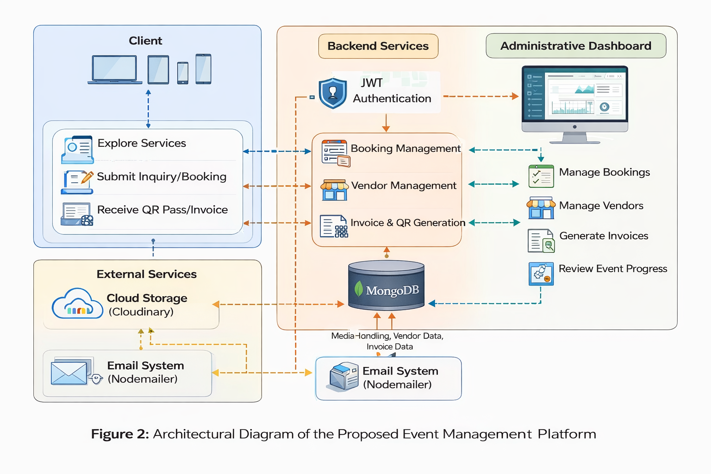
Figure 2: Architectural Diagram of the Proposed Event Management Platform
The architectural diagram illustrates the interaction between the client interface, backend services, database layer, and external services such as cloud storage and email systems. This layered architecture ensures separation of concerns, scalability, and secure data flow across the platform.

10. REFERENCES
- Laudon, K. C., & Traver, C. G. (2020). E-commerce: Business, Technology, Society (16th ed.). Pearson Education.
(Referenced for digital platforms, workflow systems, and online service models.)
- Sommerville, I. (2016). Software Engineering (10th ed.). Pearson Education.
(Referenced for system design, requirement analysis, and development methodology.)
- Pressman, R. S., & Maxim, B. R. (2019). Software Engineering: A Practitioner’s Approach (9th ed.). McGraw-Hill.
(Referenced for SDLC, modular architecture, and system scalability.)
- MongoDB Inc. (2024). MongoDB Documentation.
https://www.mongodb.com/docs/
(Referenced for database design and NoSQL data management.)
- OpenJS Foundation. (2024). Node.js Documentation.
https://nodejs.org/en/docs
(Referenced for backend development and server-side architecture.)
- Fielding, R. T. (2000). Architectural Styles and the Design of Network-based Software Architectures. Doctoral Dissertation, University of California, Irvine.
(Referenced for RESTful API architecture.)
- Ministry of Commerce and Industry, Government of India. (2024). Startup India Initiative.
https://www.startupindia.gov.in
(Referenced for startup framework and compliance understanding.)
- Event Marketing Institute. (2023). Trends in Corporate and MICE Event Management.
(Referenced for industry practices and professional event workflows.)

